Data Analytics Assignment
Summary sheet by Miss Ruth
This presentation focuses on analyzing financial transaction The dataset provided contains deposit and payment records across two sheets: “Raw Data” and “Transaction ID Record.” The primary objective is to extract valuable insights using data cleaning techniques, pivot tables, and pivot charts. The analysis covers deposit patterns by month, customer activity, payment channels, age groups, gender distribution, and bank usage. Through this process, meaningful trends are identified and visually represented to support strategic recommendations

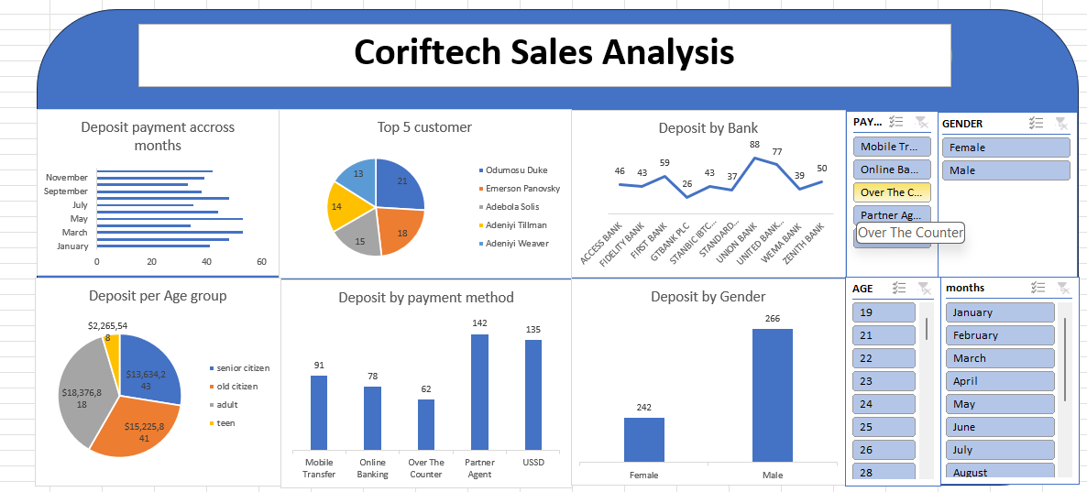

1. Q&A Section
- Q: Which age group contributed the highest total deposit value?
A: The adult age group contributed the highest deposit, with a total of $18,376.86 across 41 entries.
- Q: What payment method was most used by customers?
A: Partner Agent was the most used method with 142 deposits, followed closely by USSD with 135 deposits.
- Q: Which bank received the highest number of deposits?
A: UNITED BANK received the most deposits, peaking at 88 transactions, followed by GTBANK PLC at 77.
- Q: How does gender impact deposit behavior?
A: Males made slightly more deposits (266) than females (242), indicating relatively balanced engagement.
- Q: Which customers made the most deposits?
A: The top customer was Odumosu Duke with 21 deposits, followed by Emerson Panovsky and Adebola Solis.

2. Key Insights
- Adults are the biggest contributors to Walmart deposits.
- Partner Agents and USSD are the preferred payment methods.
- Deposit volume peaked in March and July, indicating possible sales cycles or seasonal behavior.
- UNITED BANK and GTBANK PLC lead in deposit activity.

3. Observations
- Most deposits happen through mobile-driven or agent-assisted channels, reflecting customer preference for convenience.
- Older citizens and teens account for the lowest deposit values, suggesting potential underserved groups.
- Male users slightly outnumber females in deposit transactions.
- Customer loyalty is concentrated, with a few top customers making a significant share of transactions.

4. Recommendations
- Enhance Partner Agent and USSD support, as they are the most used methods.
- Target marketing toward the adult age group, who are the primary contributors.
- Encourage engagement from seniors and teens through incentives or tailored offerings.
- Maintain strong partnerships with banks like UNITED BANK and GTBANK PLC to ensure smooth transactions and expand reach.

